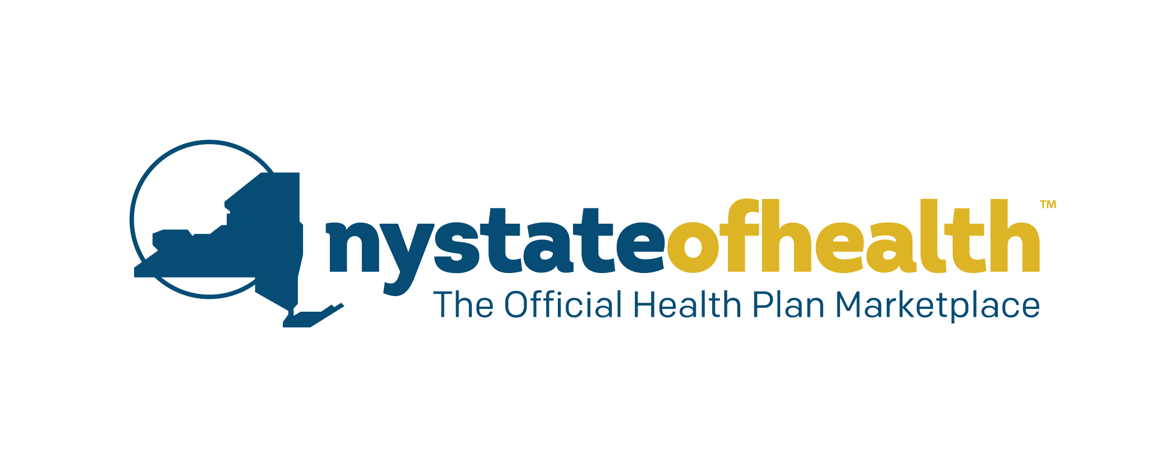
Social Media Posts
For American Rescue Plan Tax Credits

NY State of Health Facebook Page - @NYStateofHealth
NY State of Health Twitter Page - @NYStateofHealth
NY State of Health Instagram Page - @NYStateofHealth
NY State of Health LinkedIn Page - @NYStateofHealth
NY State of Health Pinterest Page - @NYStateofHealth

Post 1 - (General)

@NYStateOfHealth is always committed to helping New Yorkers get access to quality, affordable health care. Through the American Rescue Plan, eligible enrollees will soon be able to receive an increase in tax credits to lower their health insurance costs, and those who have higher incomes may be eligible for the first time. on.ny.gov/3cCxqBz #EnrollNY #TaxCredits #AmericanRescuePlan [Link to American Rescue Plan Info Page]

Post 2 - 4/1 (General)

Exciting updates are coming soon! If you enrolled in a health plan through @NYStateOfHealth, you may be eligible to receive more tax credits to help with the cost of coverage. Learn more about how the American Rescue Plan affects your coverage. on.ny.gov/3cCxqBz #EnrollNY #HealthInsurance #AmericanRescuePlan [Link to American Rescue Plan Info Page]
Post 3 - 4/5 (General)

New Yorkers, @NYStateOfHealth has exciting news! Through the American Rescue Plan, increased tax credits are now available to lower the cost of health coverage for eligible individuals and families. Higher tax credits are available to current and new enrollees, including higher income individuals for the first time. bit.ly/2O27WUs #EnrollNY #AmericanRescuePlan #HealthInsurance #NY [Link to Increase Tax Credit Video]
Post 4 - 4/14 (Consumers Under 400% FPL Who Are Not Enrolled)

Considered enrolling in the past but couldn’t find a health plan to fit your budget? More individuals and families than ever before are now eligible for new tax credits that lower the cost of health coverage even more. Shop for a plan and enroll today through @NYStateOfHealth. on.ny.gov/3cCxqBz #EnrollNY #HealthCare #NYS #AmericanRescuePlan [Link to American Rescue Plan Info Page]

Post 5 - 4/17 (Update Your Account For Current Consumers Under 400%FPL)
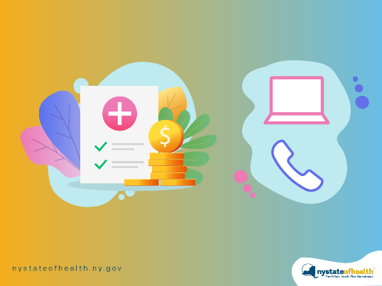

New, increased tax credits are now available to eligible New Yorkers! If you are already enrolled, increase your tax credit amount. If you are new to the @NYStateOfHealth Marketplace, visit on.ny.gov/3cCxqBz, or call 1-855-355-5777. This will help ensure you receive the new tax credits you qualify for under the American Rescue Plan. #AmericanRescuePlan #HealthInsurance [Link to American Rescue Plan Info Page]

Post 6 - 4/21 (Currently Enrolled Consumers under 400% FPL)

Did you know you could start paying less for your health plan? New federal financial help through the American Rescue Plan can increase the premium tax credits you are already receiving if you are currently enrolled in a Qualified Health Plan. These tax credits are available now through @NYStateOfHealth. bit.ly/2O27WUs #AmericanRescuePlan #TaxBenefits [Link to Increase Tax Credit Video]

Post 7 – June 2021 (Consumers above 400% FPL)

@NYStateOfHealth has important information for New Yorkers! Under the American Rescue Plan, tax credits are now available to individuals with higher incomes who previously did not qualify for financial assistance. on.ny.gov/3cCxqBz #AmericanRescuePlan #HealthInsurance #TaxCredits #GetCovered [Link to American Rescue Plan Info Page]

